Guide: compass Done

<https://fontawesome.com/v5.15/icons/compass?style=solid>

Blog: pencil Done

<https://fontawesome.com/v5.15/icons/pencil-alt?style=solid>

Mathematic science: (atom doesn’t show up) <https://fontawesome.com/v5.15/icons/atom?style=solid>

Computer science: computer

<https://fontawesome.com/v5.15/icons/desktop?style=solid>

Statistics: chart-line done

<https://fontawesome.com/v5.15/icons/chart-line?style=solid>

Cookbook: knife and fork Done

<https://fontawesome.com/v5.15/icons/utensils?style=solid>

Vocal: vinyl record Done

<https://fontawesome.com/v5.15/icons/record-vinyl?style=solid>

Logbook: book done

<https://fontawesome.com/v5.15/icons/book?style=solid>

Twist: 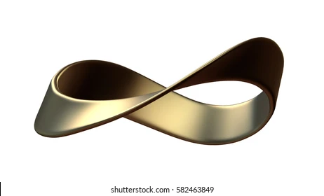 mobius strip

Living with a disability: person with cane done

<https://fontawesome.com/v5.15/icons/blind?style=solid>

Reading: book open Done

<https://fontawesome.com/v5.15/icons/book-open?style=solid>

Science communications: satellite Done

<https://fontawesome.com/v5.15/icons/satellite?style=solid>

Nanotip: microscope Done

<https://fontawesome.com/v5.15/icons/microscope?style=solid>

Identities: people arrow Done

<https://fontawesome.com/v5.15/icons/people-arrows?style=solid>

latex to mathml: MathML logo

Mathamathal usability: (need to think)

Project27 side development: site map

<https://fontawesome.com/v5.15/icons/sitemap?style=solid>

issue tracking: exclamation-triangle

<https://fontawesome.com/v5.15/icons/exclamation-triangle?style=solid>

Grapheel archive: archive file done

<https://fontawesome.com/v5.15/icons/file-archive?style=solid>

Mathematics: calculator done

<https://fontawesome.com/v5.15/icons/calculator?style=solid>

Complex numbers: (for now skip)

Difficult equations: (for now skip)

Vectors: (for now skip)

Classical mechanics: cogs done

<https://fontawesome.com/v5.15/icons/cogs?style=solid>

Kinematics: (for now skip)

Dynamics: (for now skip)

Oscillations: 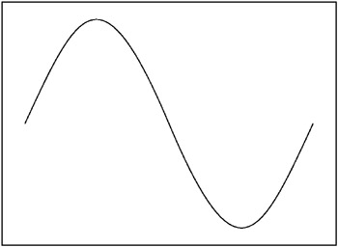 change

<https://fontawesome.com/v5.15/icons/wave-square?style=solid>

Quantum mechanics: 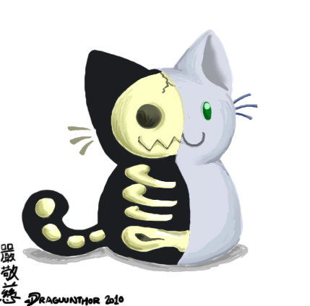schrodinger cat

Statistics explained: square root Done

<https://fontawesome.com/v5.15/icons/square-root-alt?style=solid>

Statistics in practice: tools on top of each other Done

<https://fontawesome.com/v5.15/icons/tools?style=solid>

Capturing stories: microphone Done

<https://fontawesome.com/v5.15/icons/microphone?style=solid>

Sharing stories: broadcast tower Done

<https://fontawesome.com/v5.15/icons/broadcast-tower?style=solid>

About: address card

<https://fontawesome.com/v5.15/icons/address-card?style=regular>

Guidelines: file signature

<https://fontawesome.com/v5.15/icons/file-signature?style=solid>

Legal: judge hammer

<https://fontawesome.com/v5.15/icons/gavel?style=solid>

Desserts: cone and ice cream done

<https://fontawesome.com/v5.15/icons/ice-cream?style=solid>

Fish: fish done

<https://fontawesome.com/v5.15/icons/fish?style=solid>

meat: drumstick bite Done

<https://fontawesome.com/v5.15/icons/drumstick-bite?style=solid>

pasta: 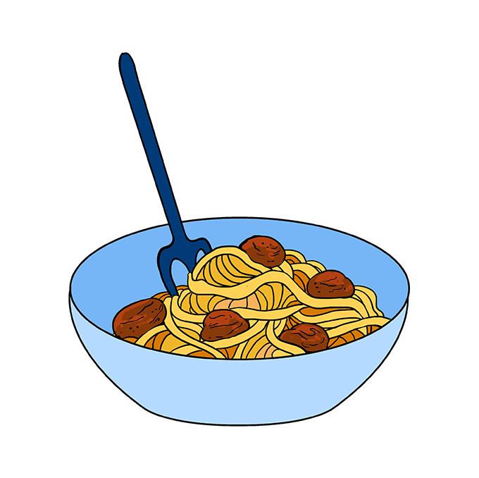 needs doing

needs doing

Soup 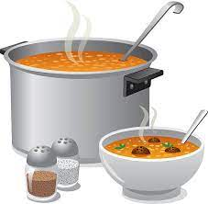 needs doing

Salad: carrot done

<https://fontawesome.com/v5.15/icons/carrot?style=solid>

Wrap: 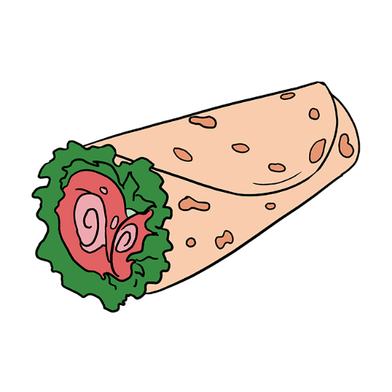 needs doing

Complex numbers: 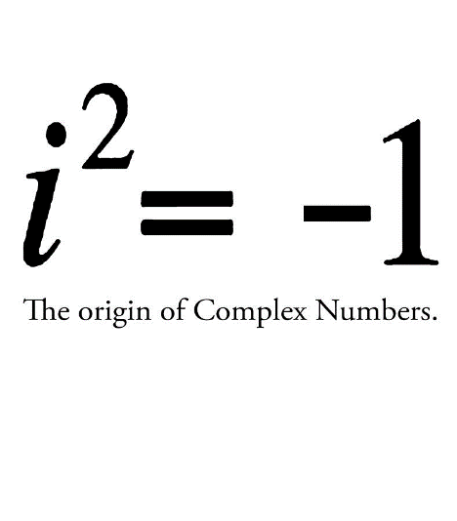needs doing

needs doing

Vectors: 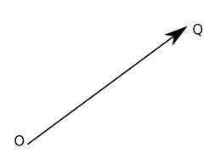need doing

need doing

Dynamics: 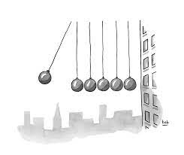need doing

Pendulum: 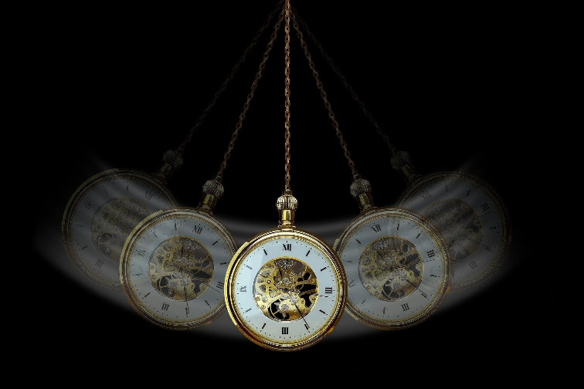 need doing

Optics: need doing

<https://fontawesome.com/v5.15/icons/search?style=solid>

Acoustics: need doing

<https://fontawesome.com/v5.15/icons/headphones?style=solid>

Blackbody radiation: 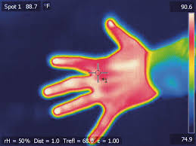 needs doing

Photoelectric effect: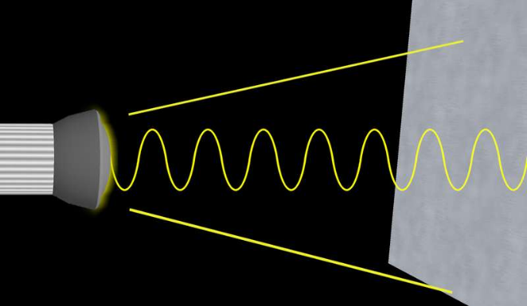needs doing